WS 1--Continuity of Operations Plan Coordinator

- Fill-in the name, title, telephone number, and e-mail address for the COOP Coordinator.

COOP Coordinator
Name | Title | Telephone Number | E-Mail

WS 2--Continuity planning team organization

- In the spaces below please list the membership of the Continuity Planning Team and the requested information for each member.

Name | Title | Telephone Number | E-Mail

WS 3--criteria for suspending all functions & services-ALL HAZARDS EXCEPT PANDEMIC INFLUENZA

- The decision to suspend all functions and services should be based on the expected duration of the emergency and the extent of the emergency.
- Set a threshold for the extent or reach of the emergency (area affected by emergency)
- AND/OR
- Set a threshold for the expected duration of the emergency

Extent of Emergency | State wide and adjoining states |  | Check One
Extent of Emergency | Multiple contiguous counties |  |  AND
Extent of Emergency | Countywide |  |  AND
Extent of Emergency | 50% to 100% of division |  |  OR
Extent of Emergency | 25 % to 50% of division |  |  OR
The mark “X” in a box for each parameter and the selection of the logical connector specifies the criteria for the suspension of all functions and services. |  |  |  | < 1 Week | 1 to 2 Weeks | 2 Weeks to 30 Days | 31 to 180 Days | More than 180 Days
 |  |  |  | Expected Duration of the Emergency

WS 4--criteria for suspending all functions & services-PANDEMIC INFLUENZA

- The decision to suspend all functions and services should be based on a combination of time since beginning of a pandemic influenza outbreak and absenteeism rate.
- Set a threshold absenteeism rate
- AND/OR
- Set a threshold time since the beginning of a pandemic outbreak

Absenteeism Rate | 50% |  | Check One
Absenteeism Rate | 40% |  |  AND
Absenteeism Rate | 30% |  |  AND
Absenteeism Rate | 20% |  |  OR
Absenteeism Rate | 10% |  |  OR
The mark “X” in a box for each parameter and the selection of the logical connector specifies the criteria for the suspension of all functions and services. |  |  |  | 2 Weeks | 4 Weeks | 12 Weeks | 6 Months | 12 Months
 |  |  |  | Time Since Beginning of Pandemic Outbreak

WS 5--incident Command system structure

- Assign individuals to each position listed in the ICS chart and identify primary, secondary, and tertiary level substitutes.

Incident Commander— is responsible for all aspects of the response, including developing incident objectives and managing all incident operations.
Unless specifically assigned to another member of the Command or General Staffs, these responsibilities remain with the IC. Some of the more complex responsibilities of the IC include:
- Establish immediate priorities especially for the safety of responders, other emergency workers, bystanders, and people involved in the incident.
- Stabilize the incident by ensuring life safety and managing resources efficiently and cost effectively.
- Determine incident objectives and strategy to achieve the objectives.
- Establish and monitor incident organization.
- Approve the implementation of the written or oral Incident Action Plan.
- Ensure adequate health and safety measures are in place.

The Command Staff—is responsible for public affairs, health and safety, and liaison activities within the incident command structure. The IC remains responsible for these activities or may assign individuals to carry out these responsibilities and report directly to the IC
Information Officer—is responsible for developing and releasing information about the incident to the news media, incident personnel, and other appropriate agencies and organizations.
Liaison Officer—serves as the point of contact for assisting and coordinating activities between the IC and various agencies and groups. This may include federal personnel, state government officials, local government officials, and criminal investigating organizations and investigators arriving on the scene.
The Safety Officer—develops and recommends measures to the IC for assuring personnel health and safety and to assess and/or anticipate hazardous and unsafe situations. The Safety Officer also develops the Site Safety Plan, reviews the Incident Action Plan for safety implications, and provides timely, complete, specific, and accurate assessment of hazards and required controls.

The General Staff— includes Operations, Planning, Logistics, and Finance/Administrative responsibilities. These responsibilities remain with the IC until they are assigned to another individual. When the Operations, Planning, Logistics or Finance/Administrative responsibilities are established as separate functions under the IC, they are managed by a section chief and can be supported by other functional units.
Operations Chief— responsible for all operations directly applicable to the primary mission of the response.
Planning Chief— responsible for collecting, evaluating, and disseminating the tactical information related to the incident, and for preparing and documenting Incident Action Plans (IAP's).
Logistics Chief— responsible for providing facilities, services, and materials for the incident response.
Finance and Administrative Chief is responsible for all financial, administrative, and cost analysis aspects of the incident.

Position | Primary Assignment | First Alternate | Second Alternate | Third Alternate
Incident Commander
Information Officer
Safety Officer
Liaison Officer
Operations Chief
Planning Chief
Logistics Chief
Finance/Admin Chief

HAZARD VULNERABILITY ANALYSIS

- In the table below evaluate the vulnerability of the organization to a wide variety of hazards.
- The scoring methodology will identify the hazards to which the organization is most vulnerable and guide preparation.
- The hazards exhibiting the highest scores, using the methodology described below require the greatest attention.

Instructions:

- Evaluate every potential event in each of the three categories of probability, risk, and preparedness.
- Add hazards that face the organization and mark those that do not as NA.
- Assign a PROBABILITY of occurrence category to each event based on:
  - known (common knowledge) risk,
  - historical data, input from experts or vendors, and
  - other sources.
- Assign a RISK category on the basis based on at least the following issues:
  - threat to life and/or health,
  - disruption of services,
  - damage/failure possibilities,
  - loss of community trust,
  - financial impact, and
  - legal issues.
- Assign a category to the level of PREPAREDNESS of your organization for each hazard based on at least the following factors:
  - status of current plans,
  - training status,
  - insurance,
  - availability of back-up systems, and
  - community resources.
- Multiply the scores as (PROBABILITY) x (RISK) x (PREPAREDNESS) and place the product in the TOTAL column.

Example
EVENT | PROBABILITY |  |  |  | RISK |  |  |  |  | PREPAREDNESS |  |  | TOTAL
EVENT | HIGH | MED | LOW | NONE | LIFE THREAT | HEALTH/ SAFETY | HIGH DISRUP-TION | MOD DISRUP-TION | LOW DISRUP-TION | POOR | FAIR | GOOD | TOTAL
SCORE | 3 | 2 | 1 | 0 | 5 | 4 | 3 | 2 | 1 | 3 | 2 | 1 | TOTAL
volcano | X |  |  |  |  | X |  |  |  |  | X |  | 24

WS 6--HAZARD VULNERABILITY ANALYSIS—natural events

EVENT | PROBABILITY |  |  |  | RISK |  |  |  |  | PREPAREDNESS |  |  | TOTAL
EVENT | HIGH | MED | LOW | NONE | LIFE THREAT | HEALTH/ SAFETY | HIGH DISRUP-TION | MOD DISRUP-TION | LOW DISRUP-TION | POOR | FAIR | GOOD | TOTAL
SCORE | 3 | 2 | 1 | 0 | 5 | 4 | 3 | 2 | 1 | 3 | 2 | 1 | TOTAL
NATURAL EVENTS
Hurricane
Tornado
Severe Thunderstorm
Snow Fall
Blizzard
Ice Storm
Earthquake
Tidal Wave/Tsunami
Temperature Extremes
Drought
Flood, External
Wild Fire
Landslide
Add as needed

WS 7--HAZARD VULNERABILITY ANALYSIS—human-initiated events

EVENT | PROBABILITY |  |  |  | RISK |  |  |  |  | PREPAREDNESS |  |  | TOTAL
EVENT | HIGH | MED | LOW | NONE | LIFE THREAT | HEALTH/ SAFETY | HIGH DISRUP-TION | MOD DISRUP-TION | LOW DISRUP-TION | POOR | FAIR | GOOD | TOTAL
SCORE | 3 | 2 | 1 | 0 | 5 | 4 | 3 | 2 | 1 | 3 | 2 | 1 | TOTAL
HUMAN INITIATED EVENTS
Mass Casualty Incident--Trauma, e.g. due to building collapse, van accident, etc.
Mass Casualty Incident (Medical), e.g. food poisonings, flu epidemic, SARs-like agents,
Hazmat Exposure
Terrorism, Chemical
Terrorism, Biological
Terrorism, Radioactive
Missing Person
Workplace Violence
Hostage Situation
Civil Disturbance
Hate Crime
Bomb Threat
Suspicious Letter
Suspicious Powder
Increased Homeland Security Alerts
Shooter in Area

WS 8--HAZARD VULNERABILITY ANALYSIS—Technological events

EVENT | PROBABILITY |  |  |  |  |  |  |  | RISK |  |  |  |  |  |  |  |  |  | PREPAREDNESS |  |  |  |  | TOTAL
EVENT | HIGH |  | MED |  | LOW |  | NONE |  | LIFE THREAT |  | HEALTH/ SAFETY |  | HIGH DISRUP-TION |  | MOD DISRUP-TION |  | LOW DISRUP-TION |  | POOR |  | FAIR |  | GOOD | TOTAL
SCORE | 3 |  | 2 |  | 1 |  | 0 |  | 5 |  | 4 |  | 3 |  | 2 |  | 1 |  | 3 |  | 2 |  | 1 | TOTAL
TECHNOLOGICAL EVENTS
Electrical Failure
Generator Failure
Transportation Failure
Fuel Shortage
Natural Gas Failure
Water Failure
Sewer Failure
Steam Failure
Fire Alarm Failure
Telephone Failure
Cellular Telephone Failure
Radios Failure
Email Communication Failure
Computer System Outage
Card Access Control System Failure
HVAC Failure
Fire, Internal
Flood, Internal
Hazmat Exposure, Internal
Unavailability of Supplies
Structural Damage

WS—9 COOP Budget

- In the spaces below identify the amounts within the organization’s budget that will provide for various essentials during an emergency.

Category | Person Responsible | Date Amount Verified | Amount
Payroll for overtime and special contract personnel
Transportation
Facilities
Food, shelter, special clothing
Utilities
Information technology infrastructure
Go-Kits and Related Supplies
Pandemic Influenza Preparedness Supplies
COOP Training
COOP Drills and Exercises
Total

WS 10--KEY RESOURCES and ACQUISITION

- Indentify key resources, such as office supplies, fuel, etc. and the primary and secondary suppliers of each resource as well as the method of communication and means of verification that the supplier or vendor has a COOP acceptable to the organization.

Key Resource | Source | Primary Means of Communication | Backup Communications | COOP  (Yes or No) | Date COOP Verified and by Whom
 | Primary
 | Secondary
 | Primary
 | Secondary
 | Primary
 | Secondary
 | Primary
 | Secondary
 | Primary
 | Secondary
 | Primary
 | Secondary
 | Primary
 | Secondary
 | Primary
 | Secondary
 | Primary
 | Secondary

ESSENTIAL fUNCTIONS

- Essential Functions are defined as those functions, stated or implied, that the organization is required to perform by statute, executive order, or organizational charter or policy and are necessary to provide vital services, maintain the safety and well-being of the employees, clients or customers, and visitors during an emergency.
- Essential functions are further delineated into Critical essential functions, Short-term essential functions, and Long-term essential functions.
  - Critical Essential Functions are those essential functions that cannot be interrupted or can be only minimally interrupted following an incident. Standard Operating Procedures (SOP) are required for all Critical Essential Functions in order to be in compliance with the CDC State Pandemic Operational Plan, indicate whether or not an SOP has been developed for each Critical Essential Function.
  - Short-term Essential Functions are those essential functions that can be interrupted for a period of up to 15 days following an incident, but must be resumed thereafter.
  - Long-term Essential Functions are those essential functions that can be interrupted for more than 15 days following an incident and will be resumed when resources and personnel become available.
WS 11--ESSENTIAL fUNCTIONS

Function | Critical Essential Function |  |  | Short-term Essential Function  Y/N | Long-term Essential Function  Y/N | Priority
Function | Y/N | N/A for N |  | Short-term Essential Function  Y/N | Long-term Essential Function  Y/N | Priority
Function | Y/N | SOP*? Y/N | During Event (I)ncrease, (D)ecrease, (U)nchanged demand | Short-term Essential Function  Y/N | Long-term Essential Function  Y/N | Priority
* Standard Operating Procedures

WS 12 - telework assignments

- During an infectious disease pandemic, some Critical Essential Functions can be performed through Telework.
- Use the following work sheet to document the assignment of personnel to Critical Essential Functions that will be performed through Telework.
- Please note that each Critical Essential Function may have more than one person assigned.

Critical Essential Function | Supervisor | Employee Assigned to CSF | Telephone Number of Employee at Telework Location

WS 13--ORDER of SUCCESSION

- Key positions are those held by executives, managers, supervisors, and critical essential functions requiring unique credentials.
- For each key position, identify the incumbent, and then by title or incumbent and title, identify the first, second, and third alternates.

Key Position | Credentials Required or NA if not applicable | Incumbent (name) | First Alternate (Title and Name) | Second Alternate Title and Name) | Third Alternate Title and Name)

WS 14--continuity FACILITIES

- Identify alternate work locations for use during an emergency. Alternate locations should exhibit the following characteristics:
  - Sufficient space, equipment, and resources to sustain an MEF
  - Capable of being operational within 12 hours after an event
  - Reliable logistical support, systems, and infrastructure support
  - Provide for the health, safety, and security of employees being relocated
  - Sufficient communication systems including secure communications, if applicable
  - Sufficient information technology and support
  - Capabilities to use virtual records necessary to sustain an MEF
- Alternate Locations may or may not be the same for Pandemic Influenza Outbreaks and All-Hazard Emergencies

Critical Essential Function | Current Location | Number of Employees | Alternate Locations

WS 15--continuity communications--INTERNAL

- In the spaces below develop an extensive communication list for all personnel in the agency or department. This list should be verified and updated monthly and is intended as a means of maintaining contact with personnel during a pandemic outbreak when many may be absent or teleworking or performing alternative duties.

Name | Work Telephone | Primary  e-mail address | Cellular Telephone | Other

WS 16--communications--EXTERNAL

- In the table below develop an extensive communication list for all key external stakeholders including other state entities, vendors, contractors, and client organizations
- Key external stakeholders may or may not be the same for Pandemic Influenza Outbreaks and All-Hazard Emergencies

Key External Stakeholder | Primary (day-to-day) Communication Method | Primary Communication Address | Redundant Communication Method | Redundant Communication Address

WS 17--VITAL RECORDS management

- The assignment is to identify the entities vital records, their format, location, and frequency of maintenance

Vital Record | Format of Record | Pre-Positioned at Continuity Facility  (Yes or No) | Hand Carried to Continuity Facility  (Yes or No) | Virtually Accessible at  Continuity Facility  (Yes or No) | Storage Location(s) | Maintenance Frequency

WS 18- Human Capital—Evacuation Rally Points

- In the table below the rally point or points for personnel following an evacuation of facilities and distribute rally points for commuters and travelers in the event that transportation arteries are unusable.

Rally Point Location (address or land mark) | Person Responsible for Taking Organizational Census at the Rally Point | First Alternate Census Taker | Second Alternate Census Taker

Human Capital—Employee PI risk assessment instrument

- Each employee should complete and sign the risk assessment instrument, the results should be compiled on the Human Capital-Organizational Census Work Sheet.

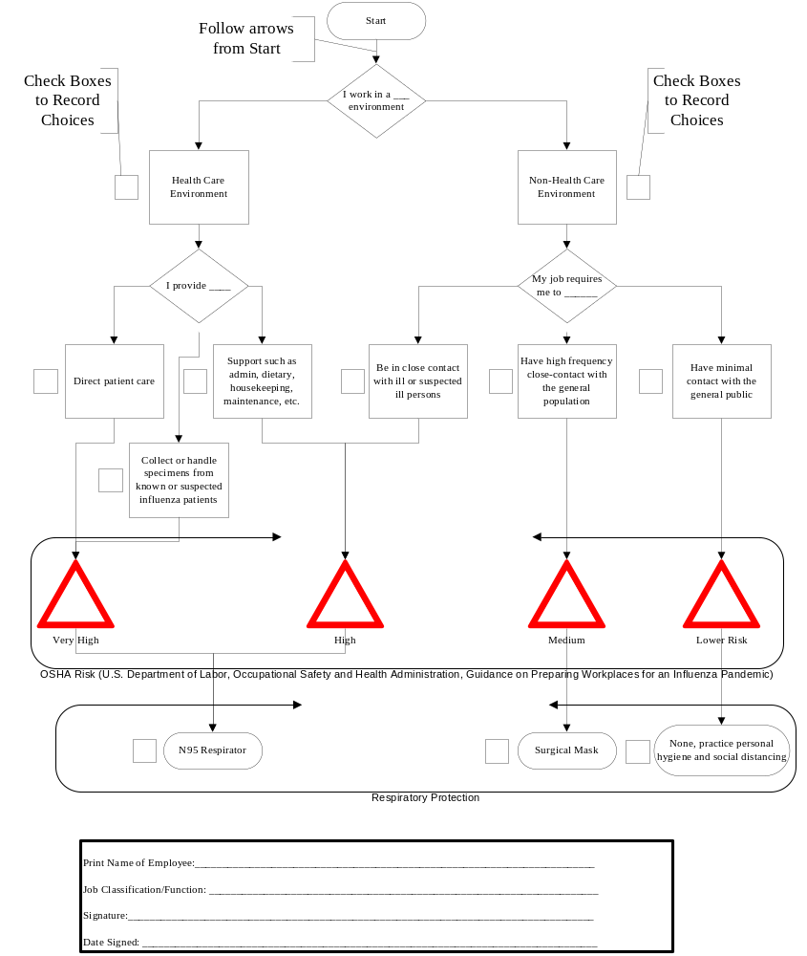

WS 19—organizational census

- In the table below identify the number of personnel in the organization in various categories

Organizational Unit | Number of Full-Time Employees | Number of Part-Time Employees | Number of Contract Employees | Total Number of Employees | Employee Pandemic Influenza Risk Assessment
 |  |  |  |  | Number of Employees
 |  |  |  |  | Very High | High | Medium | Lower Risk
WS 20 - EMPLOYEE INFLUENZA MONITORING AND TRACKING FORM

In the event of a severe pandemic, your agency may be asked to report workforce levels to the Governor’s office
Date | Employee | Date Employee or Family Became Ill with Flu | Date Expected to Return to Work | Mental Health and Social Services Needed  Y/N

WS 21—All hazards testing, training, and exercise program

Event | Training  (X or blank) | Exercise  (X or blank) | Date | Location | Attendance Expected
[add rows as needed]

WS 22—Pandemic Influenza testing, training, and exercise program

Organization Unit | Date of Equipment and Procedure Tested | Date of Essential Function Cross- Training | Date of Ancillary Staff Training | Date of PI Personnel Guidelines Training | Date of PI Training* | Date PI Exercise | Date Employees Trained on State PI OP Plan
*Examples may include, but not limited to infection control, pandemic awareness, COOP, and personal preparedness.

WS 23--reconsitution operations

- Identify the person/position responsible for recruiting replacement employees and certifying workplace safety.

Essential Function | Type  (C, ST, or LT) | Priority | Recruiting Replacement Employees  (Name and Position or Position) | Certification of Workplace Safety  (Name and Position or Position)

