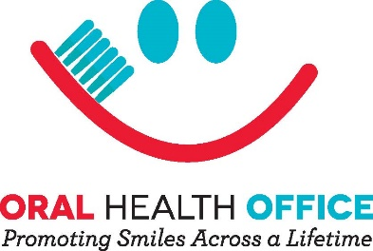
Date Click or tap to enter a date.

- Name: Click or tap here to enter text.
Alabama Dental Affiliation (DMD, DDS, RDH, CDHC, CDA): Click or tap here to enter text.
Office Name and Address: Click or tap here to enter text.
Alabama License Number: Click or tap here to enter text.
Email: Click or tap here to enter text.

- At what trimester should an expectant parent be tracking their fetal movement? (11 points)
☐1st trimester
☐2nd trimester
☐3rd trimester
☐4th trimester

- Expectant parents should avoid all dental care during pregnancy. (11 points)
☐True
☐False

- Dental providers should avoid discussing Count the Kicks with patients. (11 points)
☐True
☐False

- A) ____________is defined as the loss of a baby before the 20th week of pregnancy (11 points)
B) _____________is the loss of a baby after 20 weeks of pregnancy
C) _____________is the death of an infant before his or her first birthday
☐A) Infant Mortality; B) Miscarriage; C) Stillbirth
☐A) Miscarriage; B) Stillbirth; C) Infant Mortality
☐A) Miscarriage; B) Infant Mortality; C) Stillbirth

- Alabama has the _____worst stillbirth rate in the country. (11 points)
☐3rd
☐2nd
☐4th

- 60-75% of women have gingivitis when pregnant and we know research shows that receiving dental care during pregnancy can improve the health of both baby and mother by reducing the risk of gum disease and poor birth outcomes. (11 points)
☐True
☐False

- When updating medical history, you can add a question to your chart for pregnant patients asking about what trimester they are in and introduce Count the Kicks. (11 points)
☐True
☐False

- At every dentist appointment it is important to ask the patient if anything has changed—including asking if they are pregnant. (11 points)
☐True, but only if they appear to be
☐False, it is a violation of HIPAA
☐False, pregnancy has no relation to dentistry
☐True, oral conditions can adversely affect pregnancy outcomes

- In the state of Iowa where Count the Kicks was developed, the stillbirth rate decreased by ______% in the first ______ years of the campaign. (12 points)
☐18 / 2
☐32 / 10
☐24 / 8
☐None of the above

2 CE hours are awarded to Alabama licensed dentists and hygienists after viewing the Training Video/associated reference materials and successful completion of this Survey

A score of 75% or greater is required to obtain CE credits

Save and submit to:
OralHealth@adph.state.al.us

