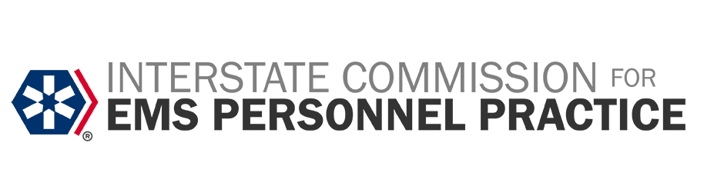
PRESS RELEASE
Interstate Commission for EMS Personnel Practice Releases Draft Rules for Public Comment
WASHINGTON, DC – The Interstate Commission for EMS Personnel Practice announces the release of draft rules designed to enhance the implementation of the EMS Compact. After extensive collaboration with commissioners, stakeholders, and the public, the Commission will meet to consider the adoption of these proposed rules on Wednesday, February 19, 2025, at 3:00 PM ET via Microsoft Teams.
“This marks a significant milestone for the EMS Compact,” said Commissioner Joe Schmider (TX), Chair of the Bylaws and Rules Committee. “After many months of collaboration and open meetings with commissioners, stakeholders, and the public, these proposed rules will provide a strong foundation for the continued advancement of the EMS Compact.”
Commission Chair Kraig Kinney (IN) added, “These rules contain some key improvements and clarifications that will help EMS Agencies, EMS Clinicians, and state officials consistently implement the EMS Compact. Notably, these rules clarify that Compact Member States can, under the EMS Compact, recognize EMS license endorsements and additional education, including—but not limited to—Critical Care Paramedic, Flight Paramedic, Community Paramedic, and expanded scopes of practice for each of these levels.”
Key highlights of the proposed rules include:
- Clarifications for EMS License Endorsements: Expanding recognition of advanced educational programs and specialized certifications.
- Enhanced Guidance on the National EMS Coordinated Database: Addressing data types, ownership, integration, and additional data protection measures.
- Introduction of a Code of Conduct: Establishing professional standards and ethical expectations for EMS Clinicians operating under the EMS Compact in all 24 Member States.
“These rules also provide significant clarity around the National EMS Coordinated Database, data ownership, and protections,” said Kinney. “Additionally, the inclusion of a Code of Conduct for EMS Clinicians is a first for the Compact, setting clear expectations for professionalism and ethics.”
Reflecting on the EMS Compact's evolution, Executive Director Donnie Woodyard stated, “In 2015, Colorado and Texas were the first to adopt EMS Compact legislation. A decade later, we now have a strong interstate compact that is a cornerstone of EMS operations across the nation. These proposed rule changes are informed by what we’ve learned over the past ten years and will serve as a solid foundation for the next decade.”
Public Comment and Meeting Details:
- The Commission invites public feedback on the proposed rules. Comments may be submitted online through THIS LINK. All comments must be received by 3:00 PM ET on February 14, 2025.
- View public comments HERE.
The public meeting to consider the proposed rules will be held:
- Date: Wednesday, February 19, 2025
- Time: 3:00 PM ET
- Location: Virtual, via Microsoft Teams
An educational session providing an overview of the proposed rules will be scheduled prior to the meeting, with the date and time to be announced. For more information on the Commission and the EMS Compact, visit www.emscompact.gov or contact the Commission at info@emscompact.gov.
###
About the Interstate Commission for EMS Personnel Practice
The Interstate Commission for EMS Personnel Practice, established under the Recognition of EMS Personnel Licensure Interstate Compact (REPLICA) legislation, is the governing body responsible for overseeing the operations of the EMS Compact. Comprised of appointed Commissioners from each member state, the Commission ensures compliance with the Compact's provisions, manages its operations, and resolves interstate disputes. ICEMSPP focuses on cross-border EMS activities, maintains a national database of EMS personnel, and upholds uniform practices across member states to enhance EMS care and public safety. Currently coordinating efforts in 24 states and overseeing nearly 400,000 EMS personnel, the Commission sets standards and regulations, promotes the profession, and ensures public protection. Interstate Compacts represent the gold standard for multistate professional licensure, facilitating seamless and efficient EMS practice across state lines.

